Vw3000 Professional Intelligent Access Control Management System Operation Manual

Revision date: September 18, 2024

Directory
(Please open the 'Document Structure Diagram' under the 'View' section, which will facilitate your reading of this manual)
Directory
Chapter 1 Basic Operation of Software 3
1.1 Login and Access to Operating Software 3
1.2 Equipment parameter settings 4
1.2.1 Add Controller 4
1.2.2 Modify door name 5
1.2.3 Setting door control mode 6
1.2.4 Change door opening delay 8
1.3 Department and Registration Card User Operations 9
1.3.1 Setting up departments 10
1.3.2 Adding Registered Card Users 11
1.3.3 Add/Remove Privilege 12
1.4 basic operation 12
1.4.1 Remote Control 13
1.4.2 Real time monitoring 15
1.4.3 Change Privilege 15
1.4.4 Upload Config 16
1.4.5 Swipe Records 17
1.5 Backup and Restore of Database 17
1.5.1 Database Storage Path 17
1.5.2 Backup and Restore 17

Chapter 1 Basic Operation of Software

Login and Access to Operating Software
- Extract the file "Vw3000English_20240727_150720.zip" and obtain the "Vw3000English" folder. Click to enter the "Vw3000English" folder.
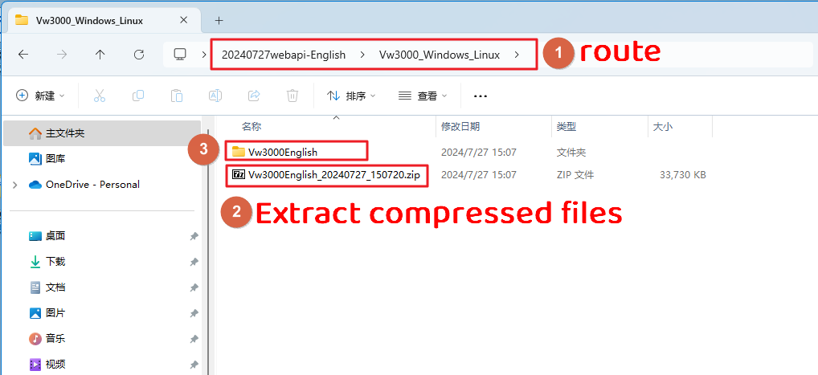
- Double click "windows-1StartVw3000. bat" → Run directly
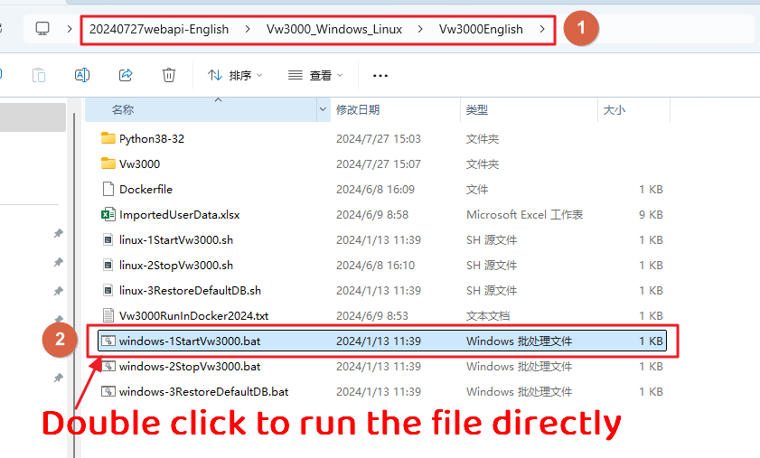
- Enter the default username: abc Password: 123, click on [Login].
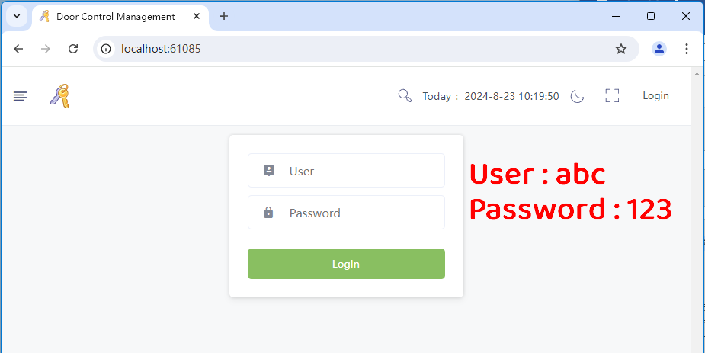
- Display the main operation interface after logging in
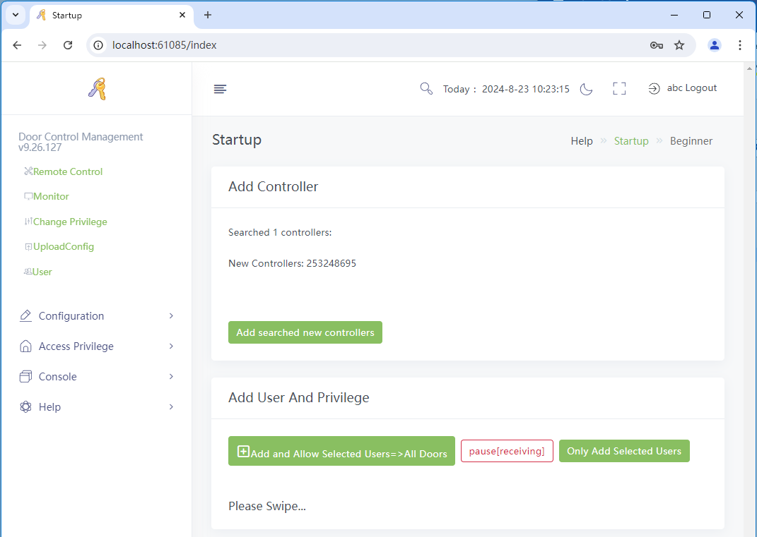

Equipment parameter settings

Add Controller
Enter the software search and add controller
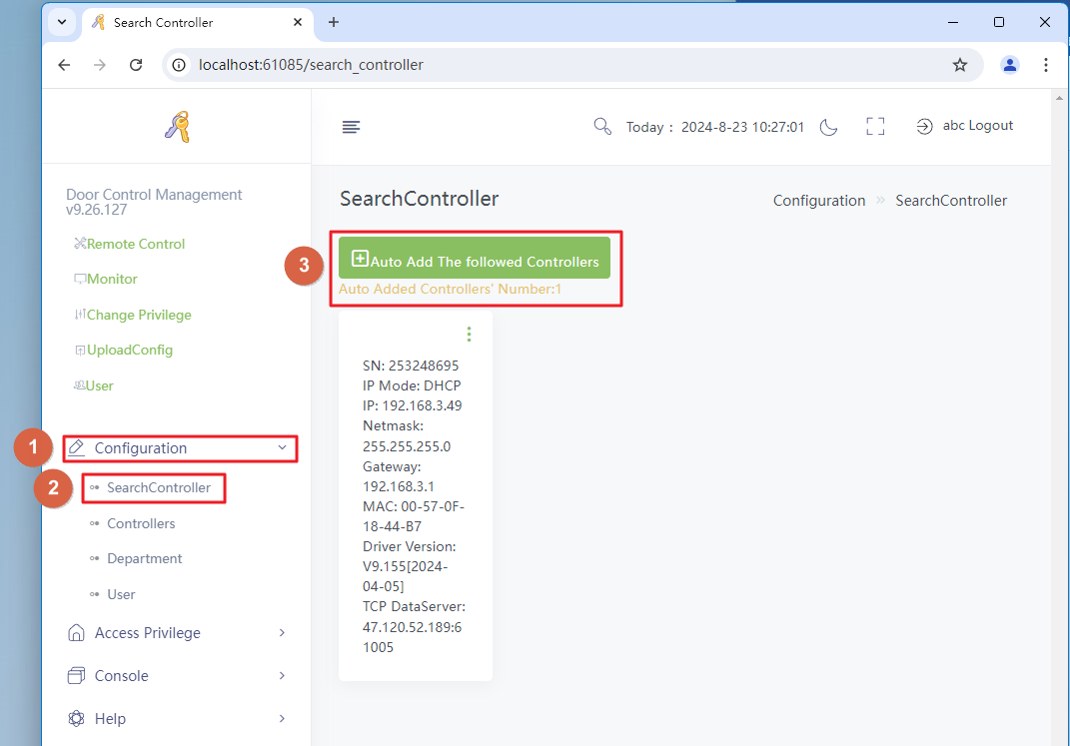

Modify door name
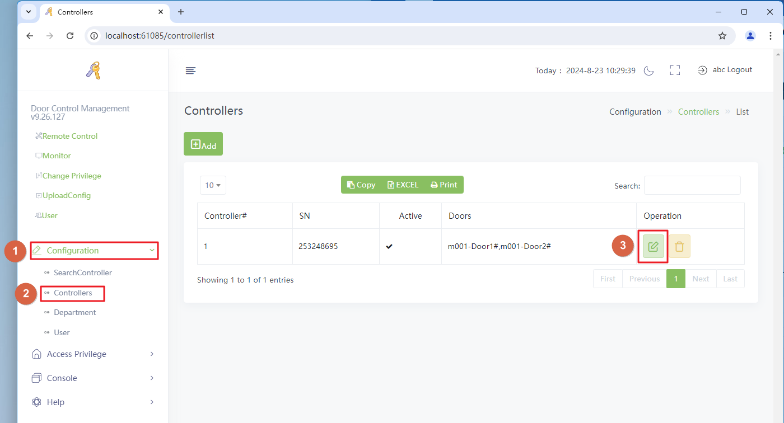
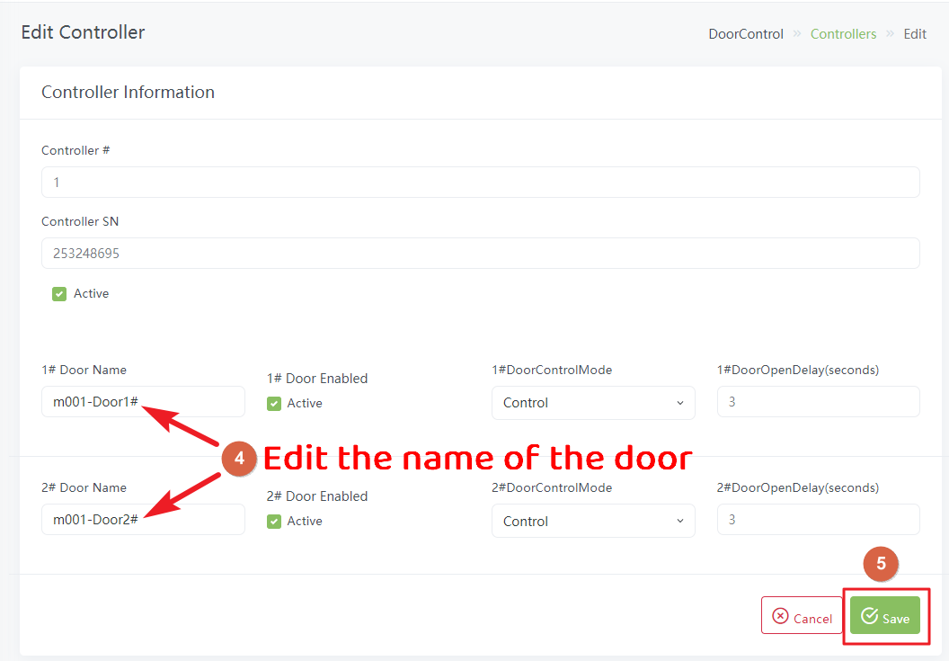

Setting door control mode
Description of door control mode：
Control：The door is in a locked state and can be opened by swiping a card, pressing a button, or remotely. After unlocking, it will automatically close after a certain period of time (delayed opening time);
Normal Open：The door is in an unlocked state and remains locked at all times;
Normal Closed：The door is locked and cannot be opened by swiping a card or pressing a button.
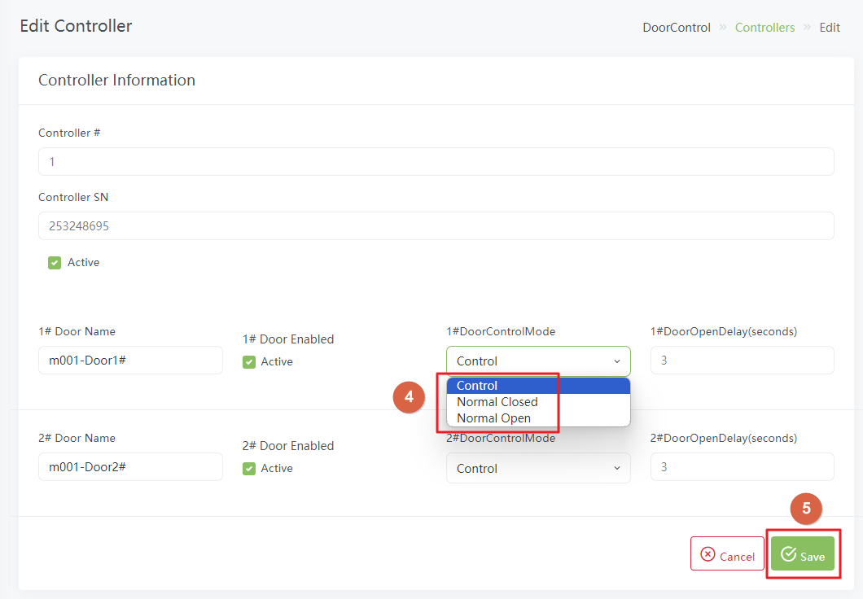
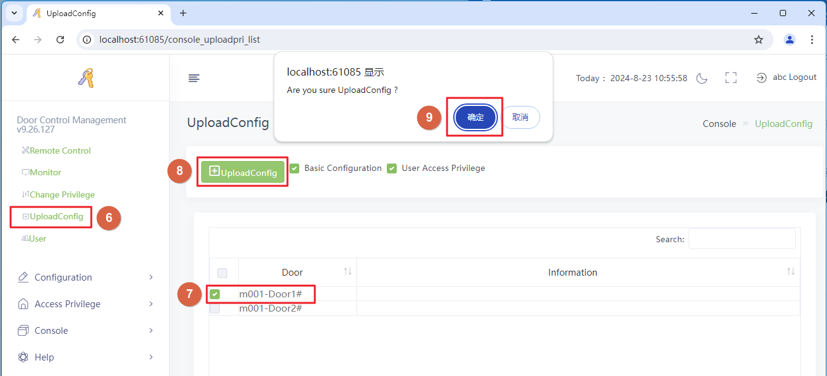

Change door opening delay
Door opening delay: After unlocking for a certain period of time (door opening delay time), the lock will automatically close.
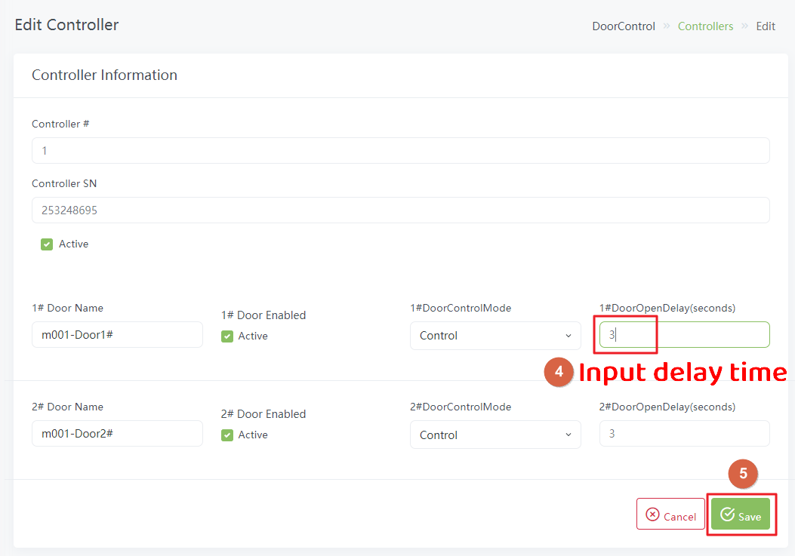

Department and Registration Card User Operations

Setting up departments
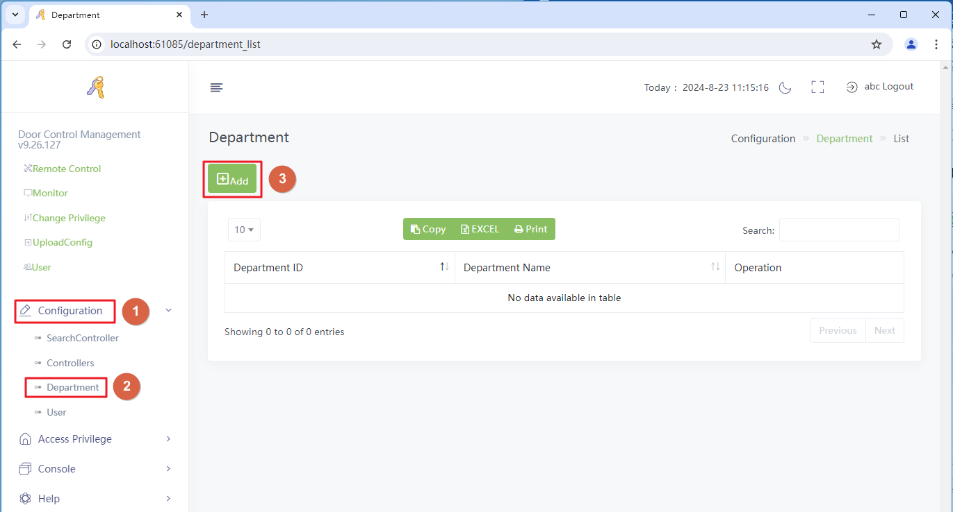
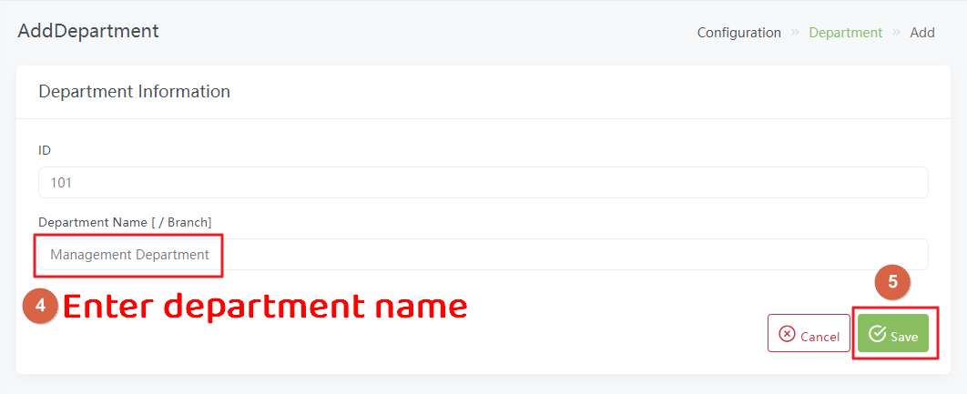

Adding Registered Card Users
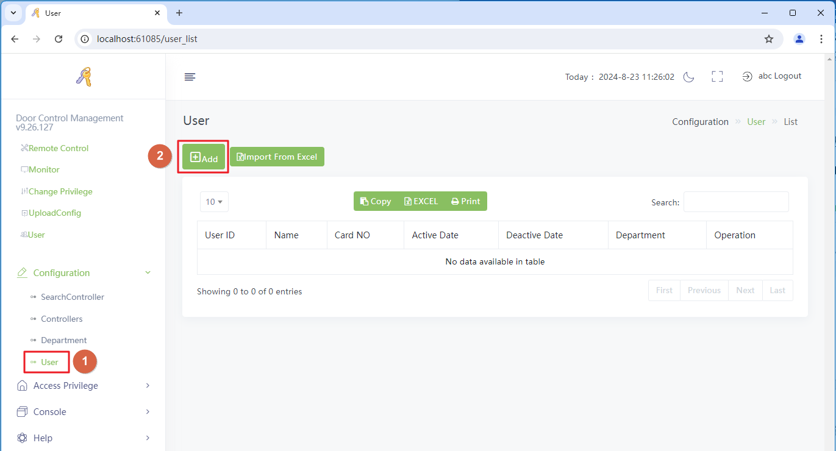
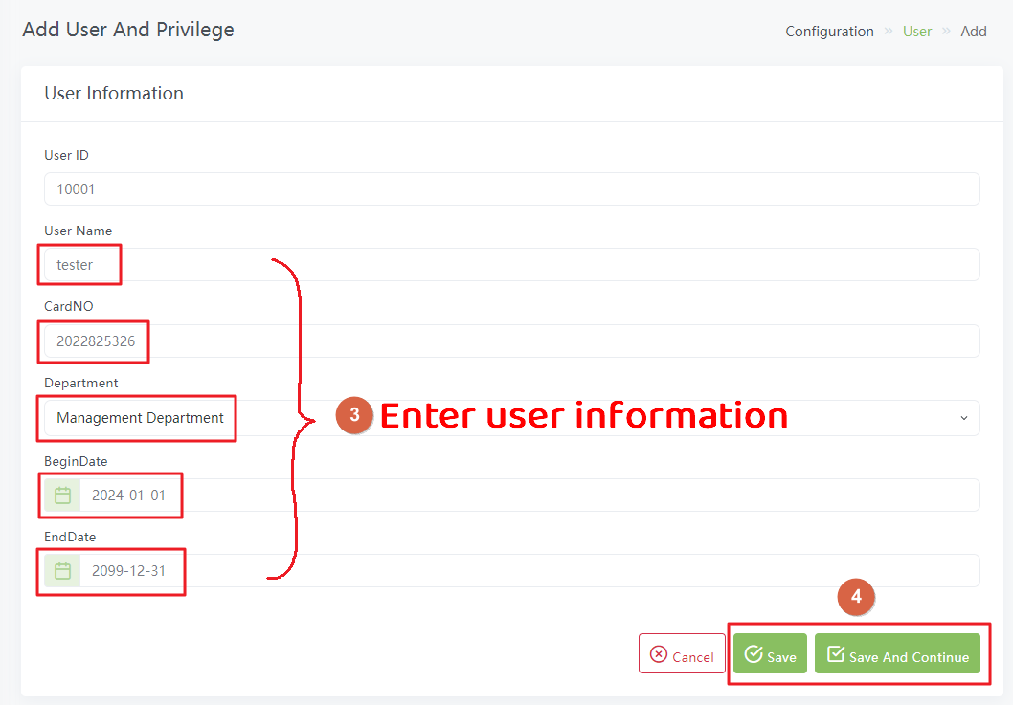

Add/Remove Privilege

Add Privilege
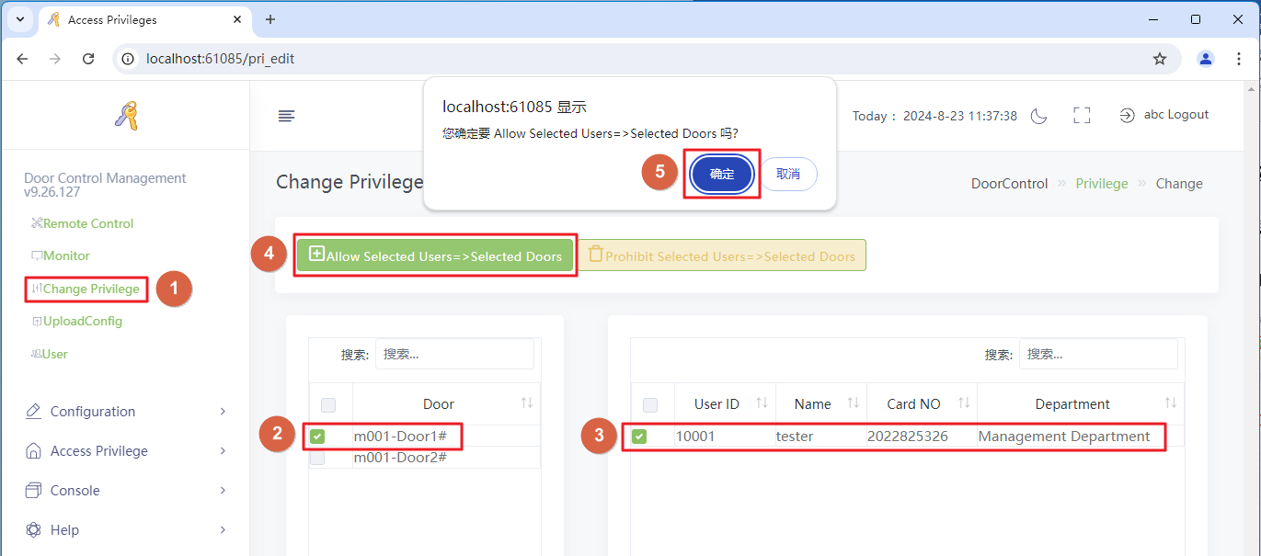

Remove Privilege
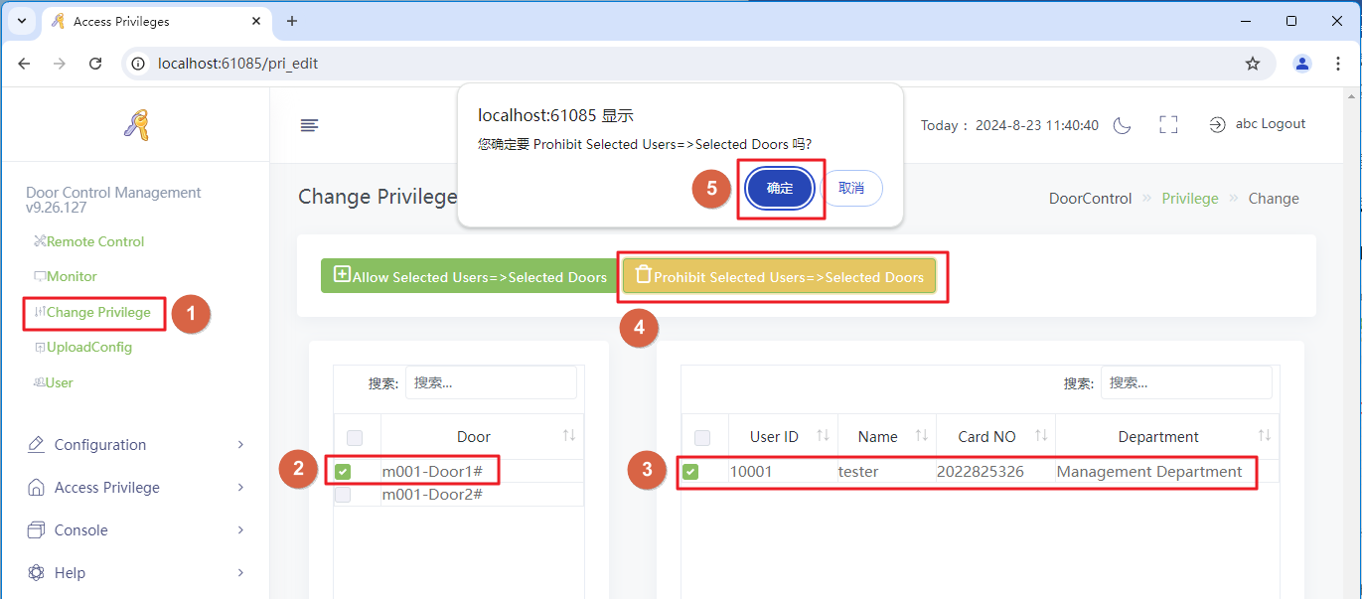

basic operation

Remote Control

Remote Door Opening
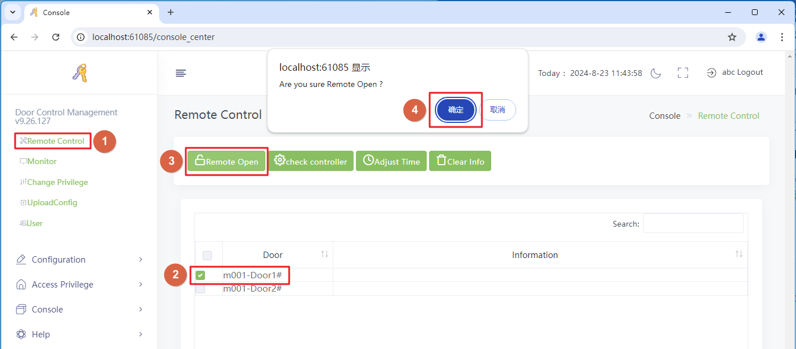

Detection Controller
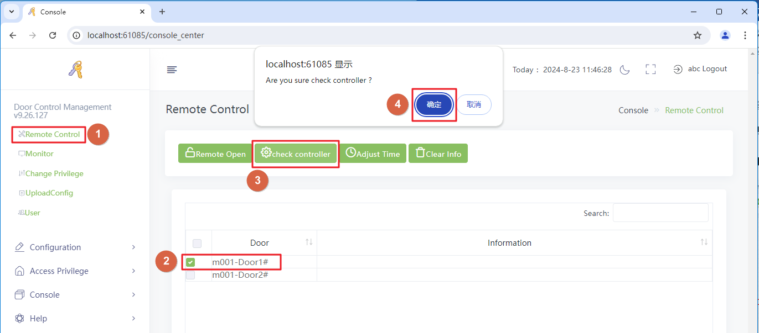

Calibration Time
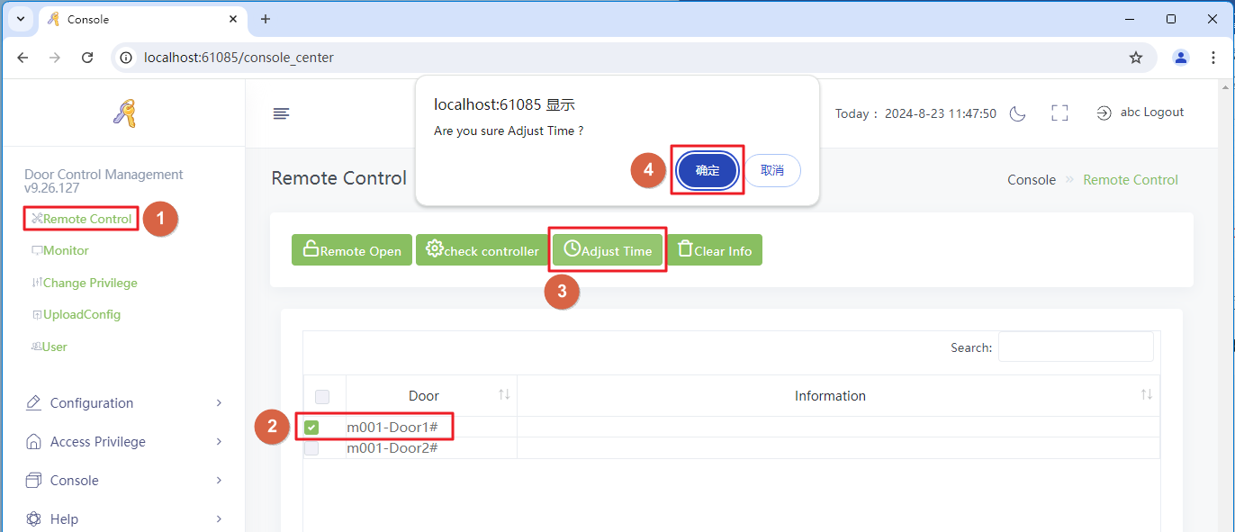

Clear Info
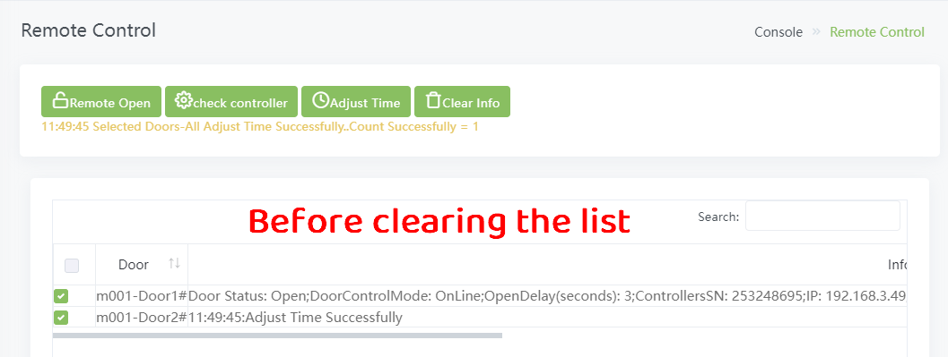
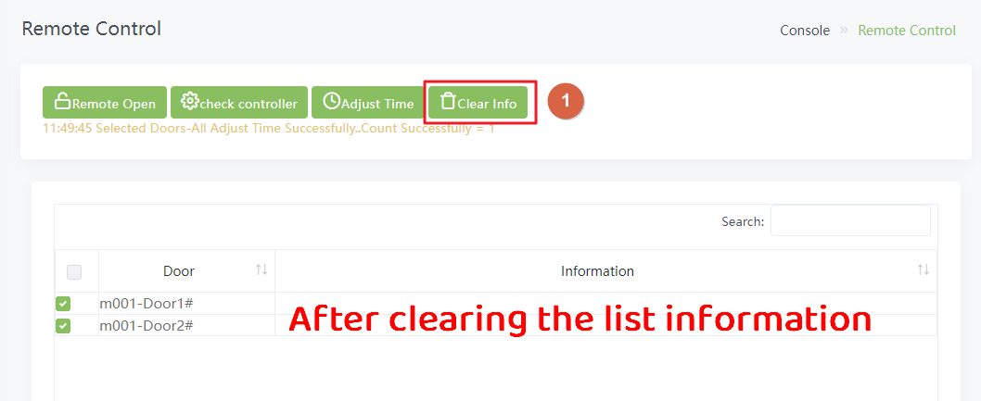

Real time monitoring
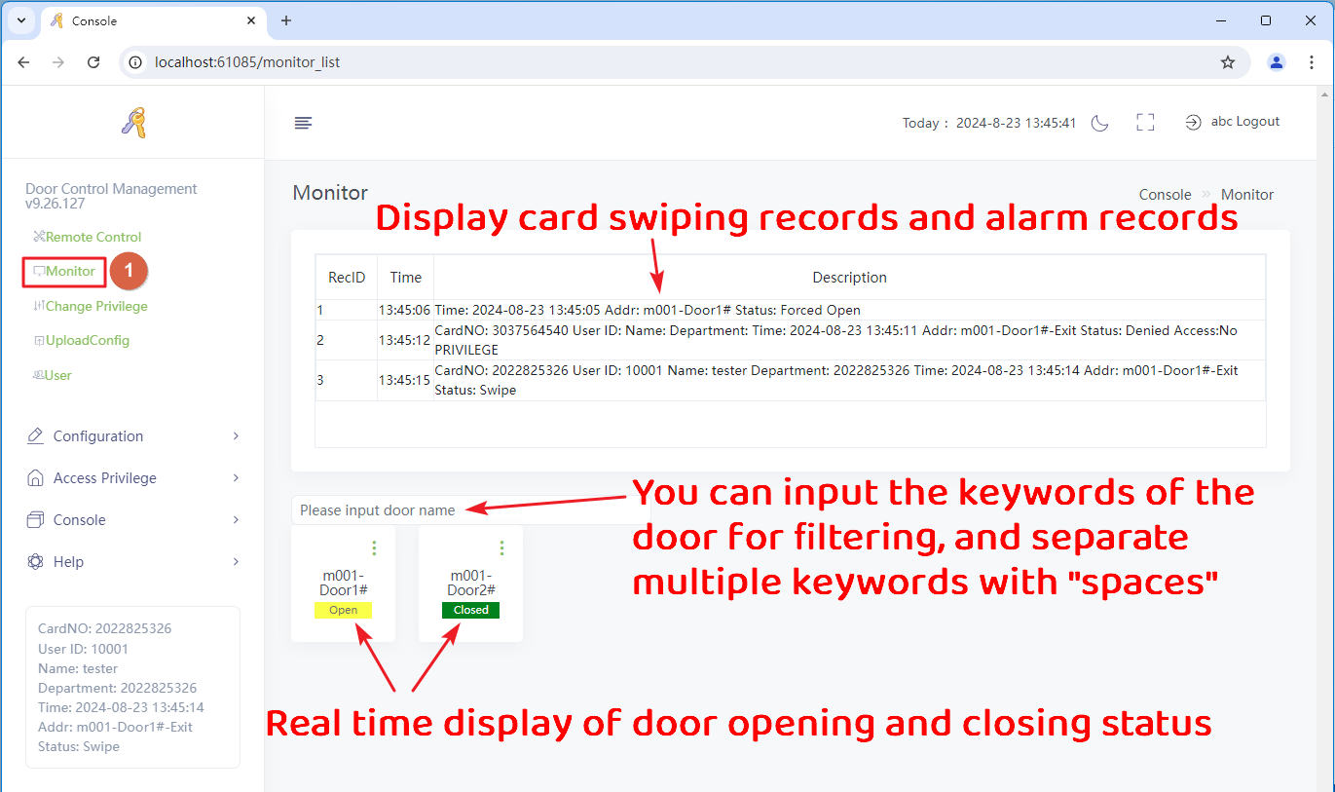

Change Privilege

Add Privilege

Remove Privilege

Upload Config
UploadConfig：Write the settings and permission list for the controller in the software into the controller.
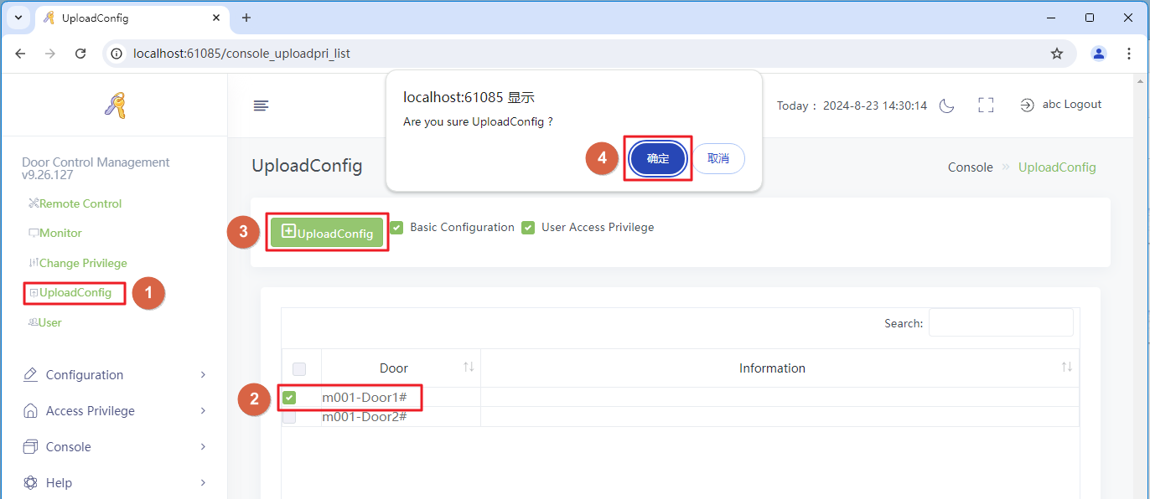

Swipe Records
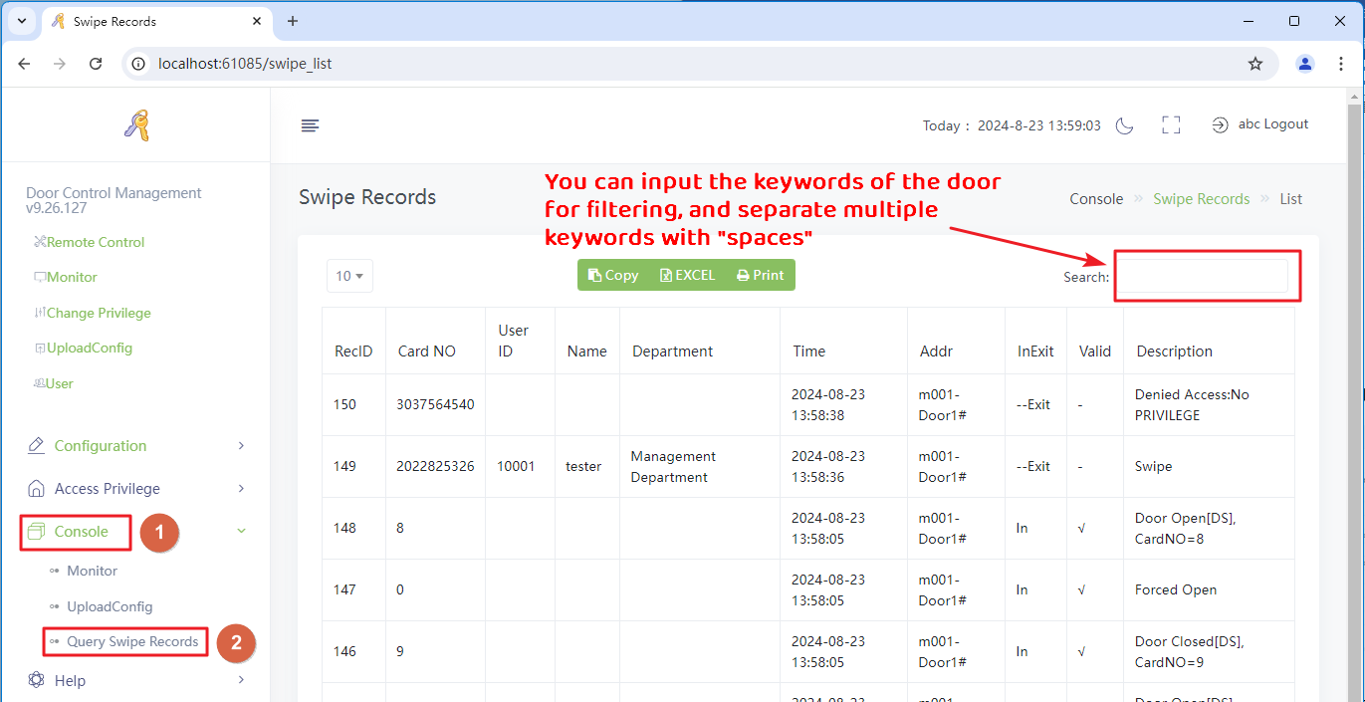

Backup and Restore of Database

Database Storage Path
Vw3000English\Vw3000\db
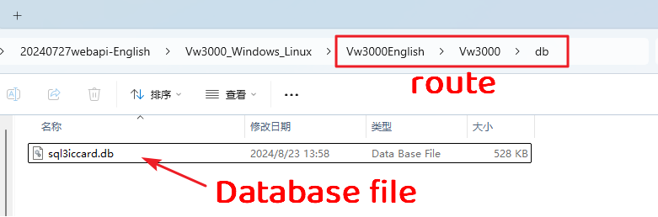

Backup and Restore
Backup: Copy the database file to another path for storage
Restore: Copy the backed up database file to the path "Vw3000English\ Vw3000 \ db" for replacement.

